Twentieth Sunday of Ordinary Time
08.18.19
STATE OF GRACE
Fr. Viviano

In the Gospel today it says “that he came to set the world on fire!” I think about those words and I think about our speaker Tim Frances who was at St. Joseph and spoke on Eucharistic Miracles on Sunday and Monday night. He seems to have set a bit of a fire. It was very interesting to me… a great, great blessing, that last night I heard confessions from four o’clock until five minutes before five. That has never happened at St. Joseph’s, but the message that they had really inspired people to understand the importance of being in a STATE OF GRACE.
I speak of that often to you…being in a STATE OF GRACE, being out of the state of grave sin, so that our souls are able to be receptive to the GRACE OF DIVINE ASSISTANCE that God has for us – the graces we might receive especially, most profoundly, in the Sacraments of the Church.
I look at a guy like Tim Francis who I can certainly relate to (considering) his past life…a drink in one hand, a girl on the other arm, bar fights. God woke him up and here he is on fire for nine years. He goes all over the country speaking about the Eucharist. He speaks about salvation. He speaks about heaven. He speaks about hell… and that is not his income. That is his ministry. It is very inspiring for me to see that.
If I asked you what is the most important thing in your life? What is the most important thing in your life? I might ask you to consider after you gave your answer that it would be your Catholic faith, because our faith, the Catholic faith, the faith that you and I belong to, is the only Church that was instituted by Almighty God. “Peter upon you I build my Church…the ROCK and the gates of hell will never prevail against no matter what…it will never prevail against it.”
We have this great mechanism, this great tool to get to heaven, primarily through the Sacraments of the Church. Of course, the beautiful gift we have in our Church is the Mass…the apex of the Mass is the Eucharist – this great gift that you and I have, mere humans, to be able to meet God in Holy Communion.
One of the things, and I will not go through Tim’s entire presentation, but a lot of his message evolved around a mystic, Catalina Rivas, from Bolivia. On the video that Tim showed you can actually see the stigmata forming on her healthy body. You can actually see it actually happening - an actual miracle happening right before your very eyes. And this woman is given this great grace of hearing Jesus and Our Lady speak to her. She has volumes and volumes of writings that she takes through dictation. And one of the things that she wrote on, that she was told about is the Holy Mass. I had a number of these sheets put together (holds up writings on the Holy Mass) and they are in the back of church. These are about what happens in the spiritual world behind what you and I experience in the concrete world here at Mass. It is a great blessing. I encourage you to read these, keep them at your bedside, read a piece here, and read a piece there to really get a sense of what is happening. Of course, we are called to take this on faith…which is a challenging with our human, rational mind, but Jesus blesses us in our faith. And we have that faith through our baptism where we receive faith, hope and charity through our holy baptism. These virtues are always with us – always. It is just a matter of connecting to them. Blessed are those who believe who have not yet seen.
So please take this (article on Catalina Rivas), read it and digest it and hopefully it will be a blessing for you the next time you come to mass.

In the name of the Father and of the Son and of the Holy Spirit…Amen!

Our Lady Queen of the Rosary
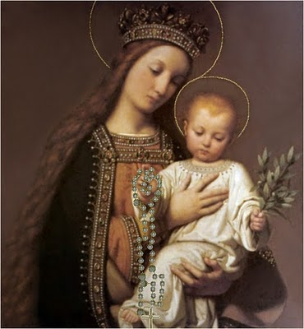
Pray for us!

